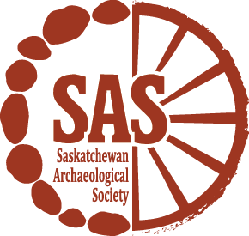
Summer Employment Opportunities
The Saskatchewan Archaeological Society (SAS) is looking for motivated individuals for the following employment opportunity:
Archaeology Youth Programs Assistant
$16.00/hour
The Archaeology Youth Programs Assistant will help the SAS reach youth through two initiatives. They will help us deliver our successful ArchaeoCaravan activities at various festivals, heritage days and culture camps throughout the province. They will also work with us to create at least five short videos to be shared on our social media platforms that highlight SAS programs and services, Saskatchewan archaeology and provincial heritage conservation and preservation.

Candidates should have experience in archaeological method and theory, preferably with a focus on public archaeology or digital applications. Ideally, the candidate will have a Bachelor's Degree in archaeology or another closely related discipline such as Indigenous Studies or History. Alternatively, a candidate with a Bachelor's degree in film or communications who is knowledgeable of Saskatchewan archaeology will also be considered. Computer competency in Microsoft Office applications is required. This project involves a human-interest component and applicants should have experience and be comfortable working with diverse audiences and public speaking. The position also requires content creation, notably short videos for the SAS social media platforms. As such the candidate must be able to shoot video footage and possess audio-video editing skills using tools such as Adobe Premier Pro or another similar editing software.

This position is open to all and we encourage applicants who belong to the Government of Canada's job equity groups (women, Indigenous peoples, persons with disabilities and members of visible minorities) to self-identify. Young Canada Works-Summer Jobs eligibility requirements require that candidates be 30 years of age or younger at the start of the position and be a current student who is returning to school full time in the Fall of 2018.

A background reference check will be required and the successful candidate will need to hold a valid driver's license as well as provide a Criminal Record Check with the Vulnerable Sector. We thank everyone for their interest and applications, however, only those selected for an Interview will be contacted.

Application Deadline: April 13th, 2018
Employment Period: May 22 – August 10, 2018
**Employment is based on student grant funding
Please submit your CV and cover letter to:
Saskatchewan Archaeological Society
1-1730 Quebec Avenue
Saskatoon, SK S7K 1V9
www.TheSAS.ca
General@TheSAS.ca

