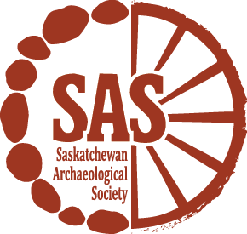
Summer Employment Opportunities
The Saskatchewan Archaeological Society (SAS) is looking for motivated individuals for the following employment opportunity:
Archaeology Project Assistant
$16.00/hour
The Archaeology Project Assistant will help the Saskatchewan Archaeological Society deliver two archaeology field schools at the Original Humboldt Site in Saskatchewan in partnership with the Humboldt and District Museum. This project focuses on historical events related to the 1885 North West Resistance as well as European settlement in Saskatchewan. It will include public archaeology excavations, artifact identification and cataloguing, data analysis and a project reporting component.

Candidates should have experience in archaeological method and theory, preferably with a focus on historical or military archaeology. Ideally, the candidate will have a Bachelor's Degree in archaeology or another closely related discipline such as History or Indigenous Studies. Computer competency in Word, PowerPoint, Excel and Outlook is required and experience with a graphic design or database program would be an asset.

This project involves a human interest component and applicants should have experience and be comfortable working with diverse audiences and public speaking.

This position is open to all and we encourage applicants who belong to the Government of Canada's job equity groups (women, Aboriginal peoples, persons with disabilities and members of visible minorities) to self-identify. Young Canada Works-Summer Jobs eligibility requirements require that candidates be 30 years of age or younger at the start of the position and be a current student who is returning to school full time in the Fall of 2018.

A background reference check will be required and the successful candidate will need to hold a valid driver's license as well as provide a Criminal Record Check with the Vulnerable Sector. We thank everyone for their interest and applications, however, only those selected for an Interview will be contacted.

Application Deadline: April 13th, 2018
Employment Period: May 22 – August 10, 2018
**Employment is based on student grant funding
Please submit your CV and cover letter to:
Saskatchewan Archaeological Society
1-1730 Quebec Avenue
Saskatoon, SK S7K 1V9
www.TheSAS.ca
General@TheSAS.ca

